**1. Install and Launch Reports Builder**

In the [Part 1 of SSRS Tutorial](https://kindsonthegenius.com/mssql/sql-server-reporting-services-ssrs-tutorial-for-beginners-part-1/#t7), we setup SSRS Server and configures SSRS. In this tutorial, we would install Reports Builder and actually build reports.

Follow the steps below:

[Download and install MS Report Builder from the link](https://www.microsoft.com/en-us/download/details.aspx?id=53613).

After installation, launch Reports Builder and you will have the window below:

[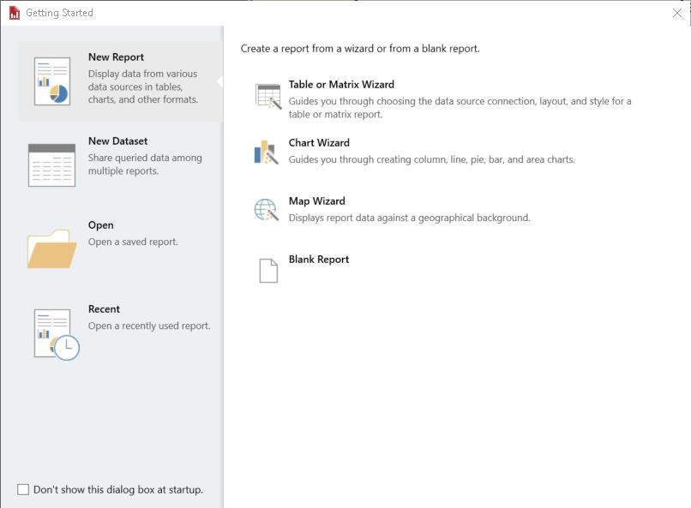](https://i0.wp.com/kindsonthegenius.com/mssql/wp-content/uploads/2022/05/Reports-Builder-Window.jpg?ssl=1)Reports Builder Window

Click on the Close(x) icon to exit this window.

At this point, you will see an empty reports page as shown below.

[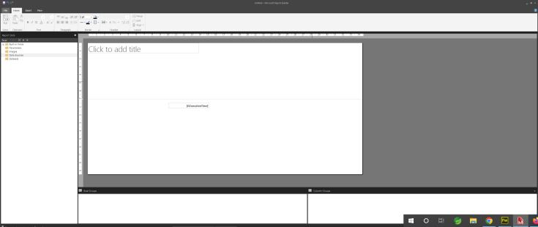](https://i0.wp.com/kindsonthegenius.com/mssql/wp-content/uploads/2022/05/Blank-Report-Page-in-Reports-Builder.jpg?ssl=1)Blank Report Page in Reports Builder

**2. Create a Data Source**

Before you can create a data source, you must have some data in a database. In this tutorial, we would using the Northwind database. This is a free database you can add using Management Studio (see the video on how to do this).

Follow the steps below to create a data source

**Step 1** – Right-click on Data Sources and choose Add Data Source. The Data Source properties window opens. Modify as shown below (you can watch the video for if you need more details on this, but it’s quite easy)

I named it MyDataSource

[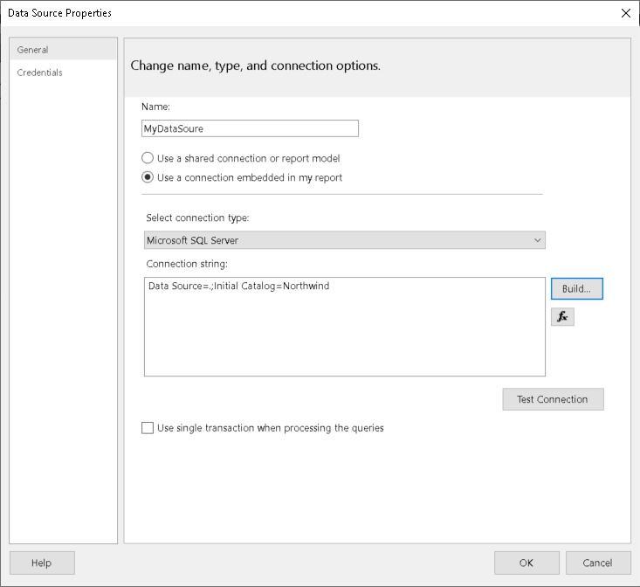](https://i0.wp.com/kindsonthegenius.com/mssql/wp-content/uploads/2022/05/Adding-a-data-source-to-Reports-Builder.jpg?ssl=1)Adding a data source to Reports Builder

**Step 2** – Click on Ok to close the window

**3. Create a Data Set**

Next we need to create a dataset.

**Step 1**– Right-click on Datasets and select Add Dataset The Dataset properties windows opens up as shown in the figure

**Step 2** – Adjust the settings as shown:

* give it a name,
* Select ‘Use a dataset embedded in my report,
* Select your Datasource under Data Source

[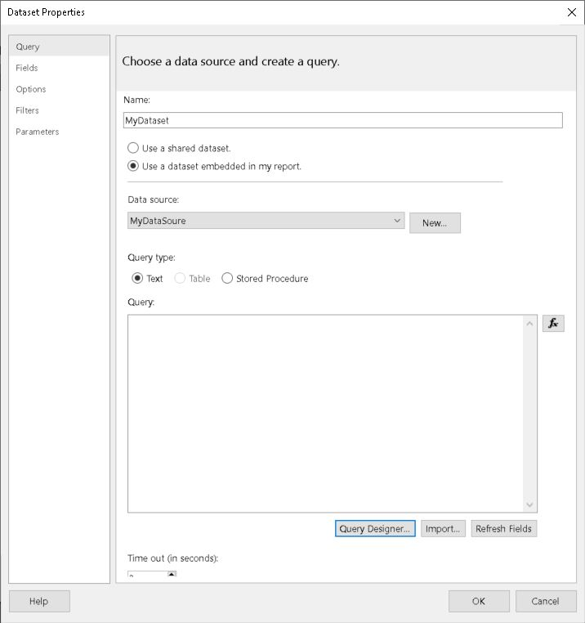](https://i0.wp.com/kindsonthegenius.com/mssql/wp-content/uploads/2022/05/Dataset-Properties.jpg?ssl=1)Add Dataset to Reports Builder

**Step 2** – Click on Query Designer to open the query designer as shown below in the Figure below:

**Step 3** – Expand Tables and select Customer

[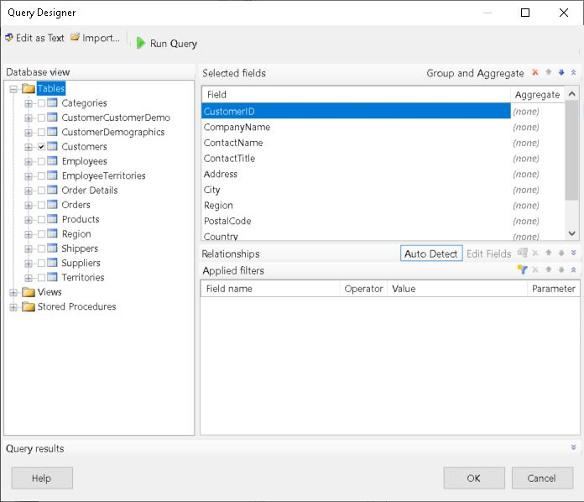](https://i0.wp.com/kindsonthegenius.com/mssql/wp-content/uploads/2022/05/Query-Designer-in-Reports-Builder.jpg?ssl=1)Query Designer in Reports Builder

Step 4 – You can click on Run Query to see the query results

Step 5 – Click on Ok to exit the Query designer

Step 6 – Click on Ok again to exit the Dataset properties window

**4. Design a Table Report**

Now we would design a Table report using our dataset

**Step 1** – Give your report a title by replacing the text “Click to Add Title”

**Step 2** – From the Insert tab, choose Table -> Table Wizard. The table wizard window opens as shown

[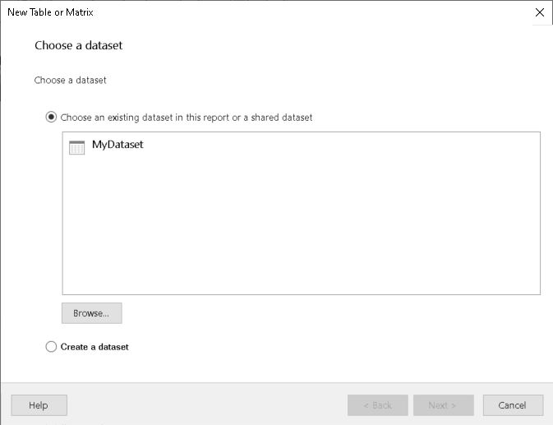](https://i0.wp.com/kindsonthegenius.com/mssql/wp-content/uploads/2022/05/Table-Wizard.jpg?ssl=1)Table Wizard

**Step 3** – Click on MyDataset and click Next

[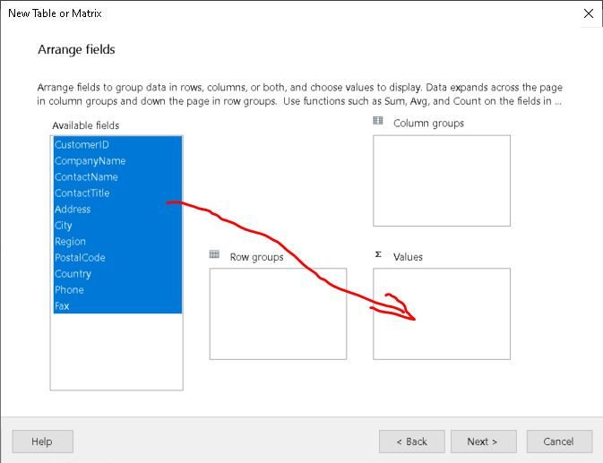](https://i0.wp.com/kindsonthegenius.com/mssql/wp-content/uploads/2022/05/Table-Wizard-Arrange-Fields.jpg?ssl=1)Table Wizard Arrange Fields

**Step 4** – Select all the fields and drag them to the Values section

**Step 5** – Click on Next -> Next again and Finish. Your report would now appear with your table as shown below:

[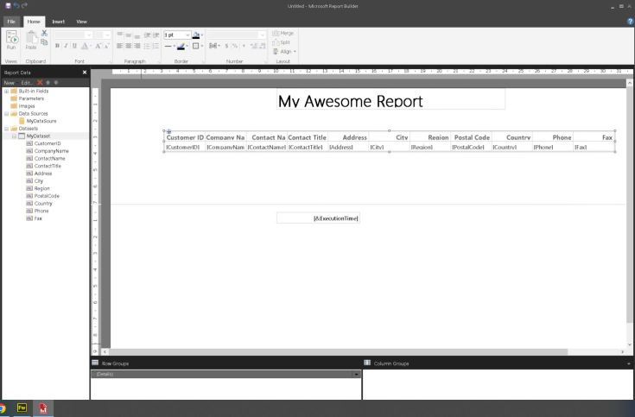](https://i0.wp.com/kindsonthegenius.com/mssql/wp-content/uploads/2022/05/Table-Report-Design.jpg?ssl=1)Table Report Design

**Step 6** – Click on Run to preview the report. You will see a list of Customers displayed. Then you can go back to design view.

**Step 7** – Click on File Save as to save the report with a name. I named it Customer.  It’s a .rdl file.

Take note of the location you are saving it.

**5. Let’s Publish Our Report!**

Now we must publish our report so that we can access it on the web. Follow the Steps below

**Step 1** – Open the Report Server Configuration Manager

**Step 2** – Click on the Web Portal Url. Click on the link to open the url on a web browser.

[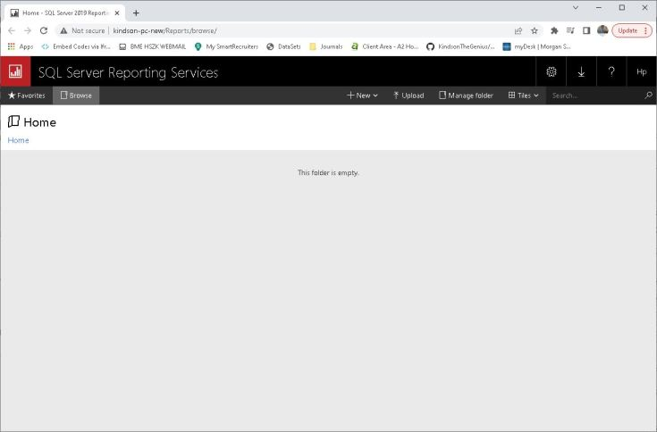](https://i0.wp.com/kindsonthegenius.com/mssql/wp-content/uploads/2022/05/Report-Service-Web-Portal.jpg?ssl=1)Report Service Web Portal

**Step 3** – Click on the Upload button and select the report you saved earlier. You Customer report shows up as a link.

**Step 4** – Click on the link to run the Report. You will see the list of customer displayed on the web page.